**HASHING**  
T=[]

for i in range (10):

T+=[[],]

m=10

def insert():

value=input("enter value to input ")

k=int(input("enter a key "))

i=k%m

T[i]+=[[k,value],]

print("insert successful")

print(T)

print()

def find():

k=int(input("enter key of value to find "))

i=k%m

found=0

for j in range(len(T[i])):

if T[i][j][0]==k:

found=1

value=T[i][j][1]

if found==0:

print("key not found darling")

else:

print("the value having key ",k," is ",value)

print()

while True:

print("1. insert")

print("2. find")

print("3. stop")

ch=int(input("enter choice "))

if ch==1:

insert()

if ch==2:

find()

if ch==3:

break

**prob set 0 qn6**  
def count_incsub(A):

count={}

k=0

L=()

L+=(A[0],)

t=0

for i in range (1,len(A)):

if A[i]>A[i-1]:

L+=(A[i],)

else:

print(L)

if len(L) in count:

count[len(L)]+=1

else:

count[len(L)]=1

L=(A[i],)

k+=1

print(L)

count[len(L)]=1

print(count)

K=count.keys()

M=max(K)

sub=count[M]

print("no. of inc subarrays ",sub)

A=()

n=int(input("enter size of tuple "))

for i in range(n):

k=int(input("enter element "))

A+=(k,)

count_incsub(A) 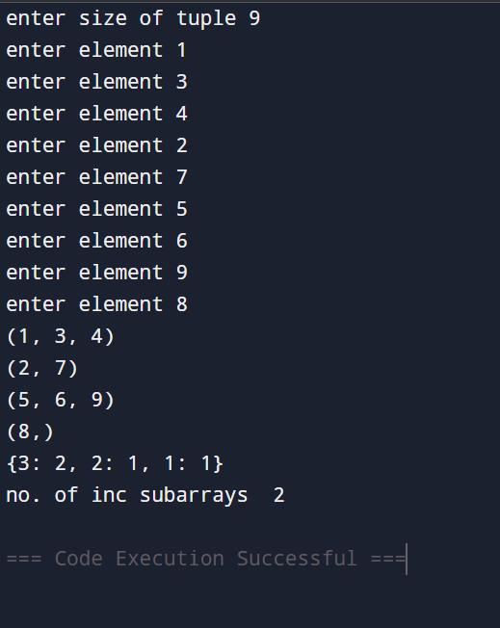

redix sort

**REDIX SORT**

**COUNTING SORT:**

A=[]

n=int(input("enter size of list "))

for i in range(n):

k=int(input("enter element "))

A+=[k,]

###############doing C-counting list

C=[]

M=max(A)

D={}

for i in range(0,M+1):

D[i]=A.count(i)

C=list(D.values())

print(C)

###############cummulative C

C1=[]

for i in range(len(C)):

C1+=[0,]

for i in range(len(C)):

S=0

for j in range(i+1):

S+=C[j]

C1[i]=S

print(C1)

##################building output

print()

B=[]

for i in range(len(A)):

B+=[0,]

for i in range(len(A)-1,-1,-1):

k=A[i]

main=C1[k]

pos=main-1

B[pos]=k

print(B)

#print(C1[k])

C1[k]-=1

print(C1)



